ASSIGNMENT-16
Htno:2503A52L14

Lab 16 – Database Design and Queries: Schema Design and SQL
Generation
Lab Objectives:
• Understand schema design principles for relational databases.
• Use AI-assisted tools to generate SQL schema definitions.
• Write and refine SQL queries (CRUD + aggregate operations).
• Explore how AI can optimize queries and ensure normalization.
Task 1 – Student Information System Schema
Task:
Design a database schema for a Student Information System and
generate queries using AI.
Instructions:
• Tables: Students, Courses, Enrollments.
• Define primary keys, foreign keys, and relationships.
• Generate queries:
o Insert a new student record.
o Fetch all courses enrolled by a student.
o Count number of students in each course.
PROMPT:
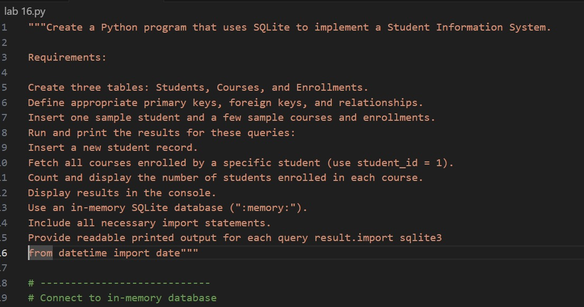
CODE:
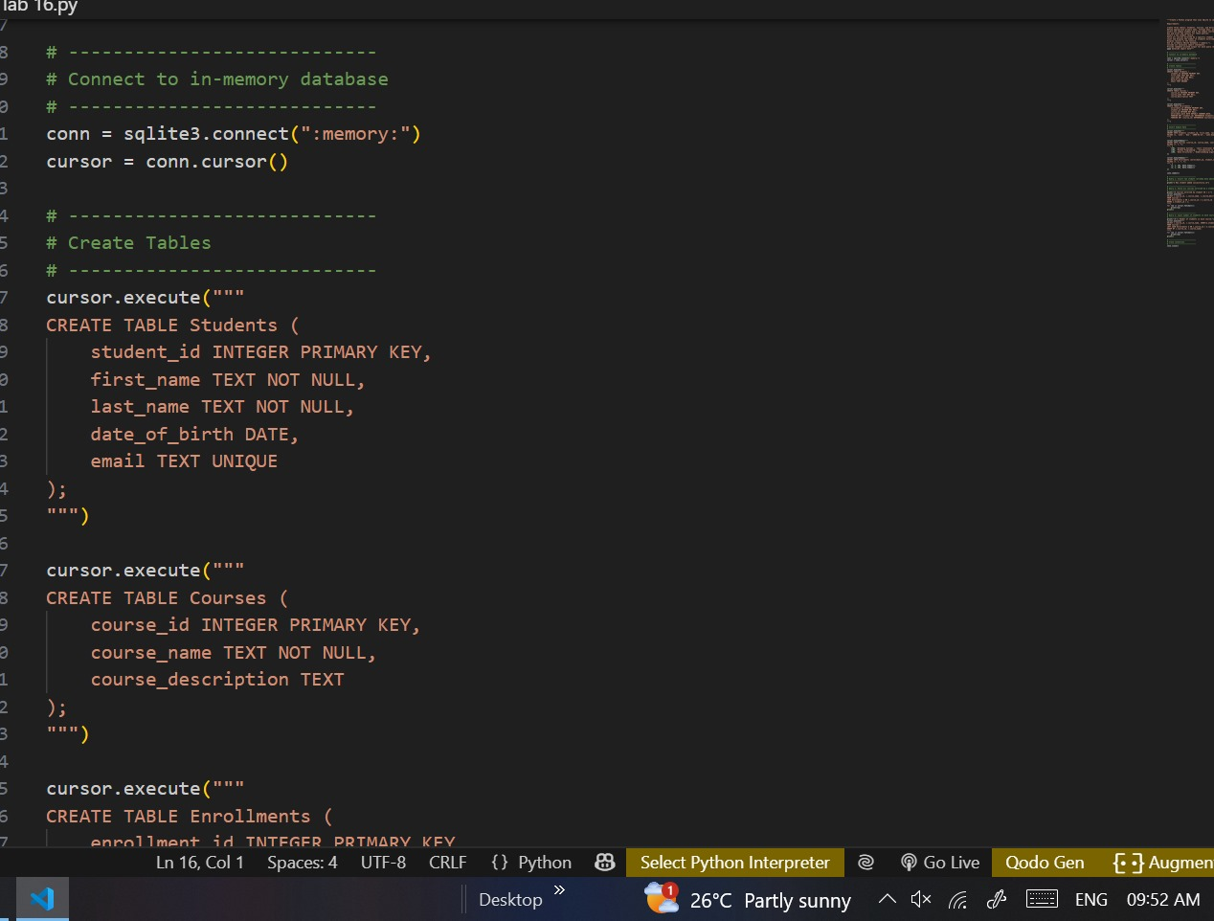

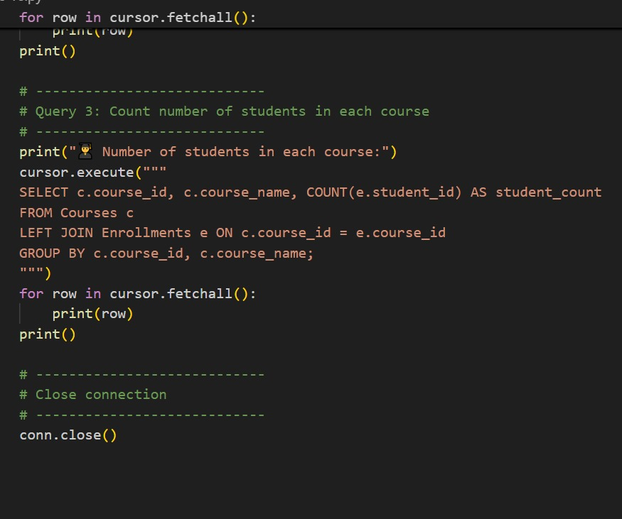
Expected Output:
• SQL CREATE TABLE statements and queries for student–course
relationships.
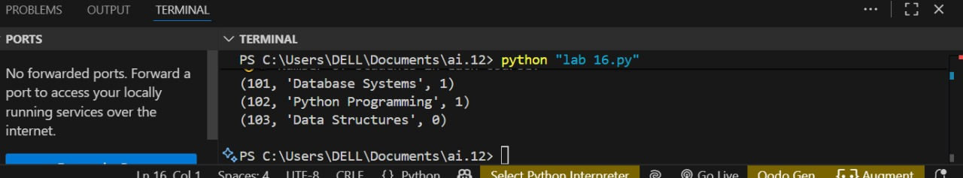

Task 2 – Hospital Management Database
Task:
Create schema and queries for a Hospital Management System.
Instructions:
• Tables: Doctors, Patients, Appointments.
• Use AI to define constraints (unique IDs, valid dates).
• Generate queries:
o List all appointments for a specific doctor.
o Retrieve patient history by patient ID.
o Count total patients treated by each doctor.

PROMPT:

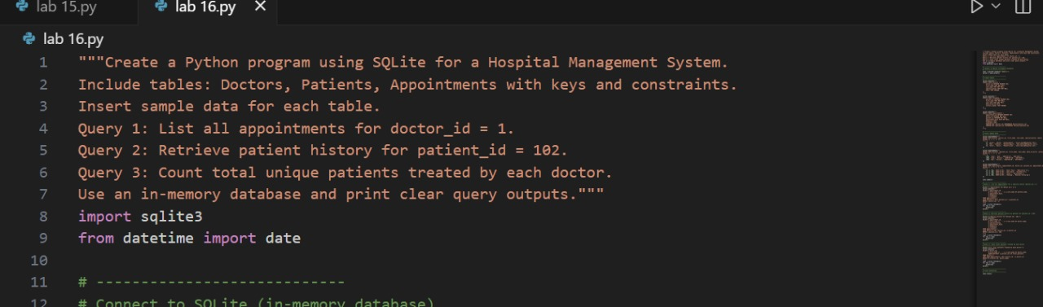

CODE:
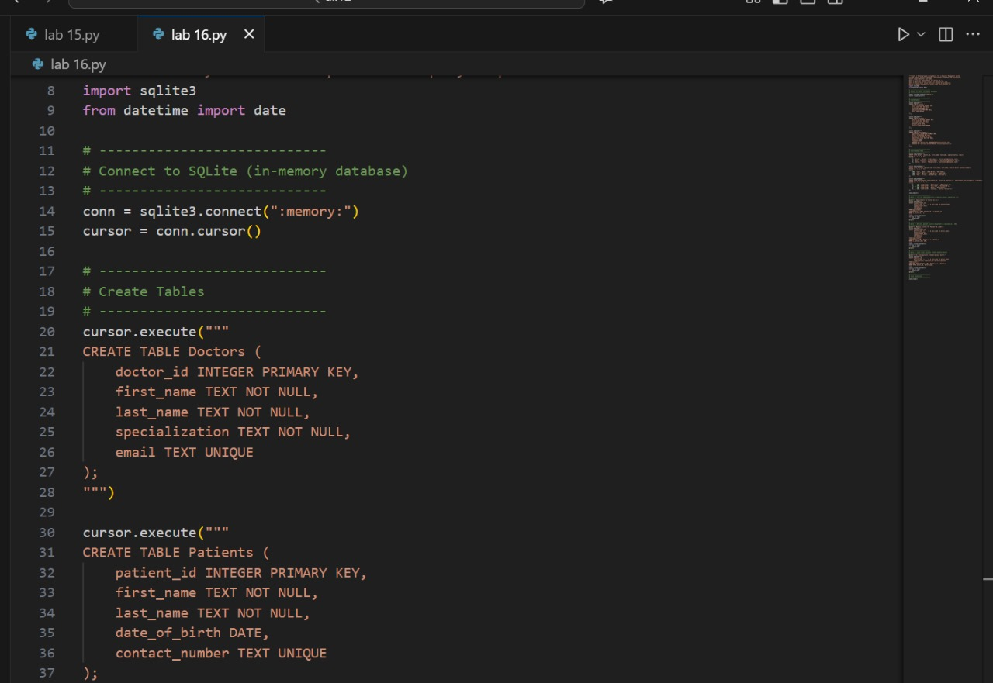

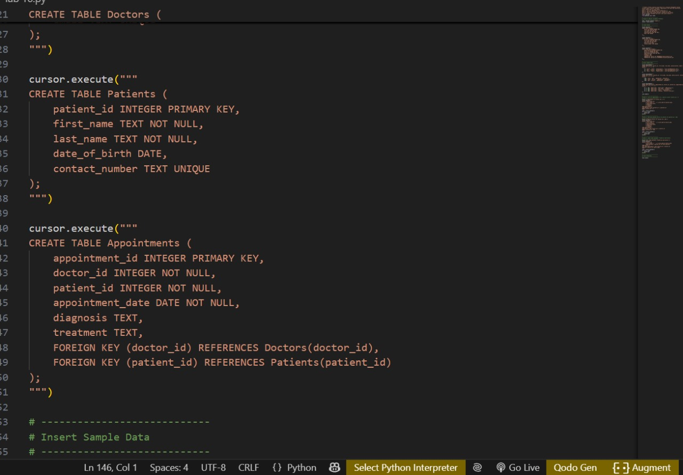
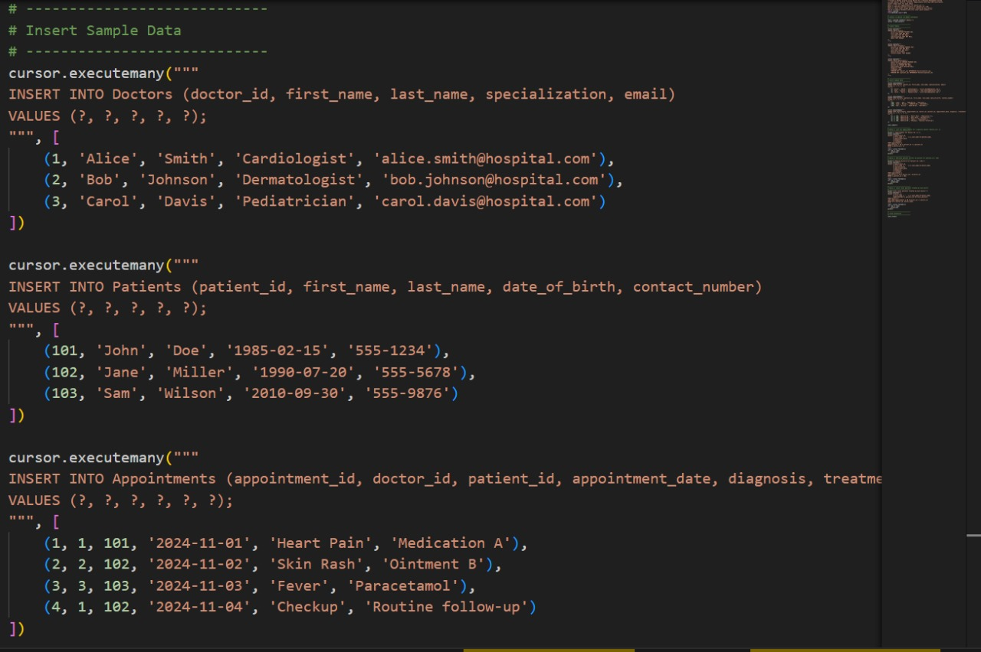

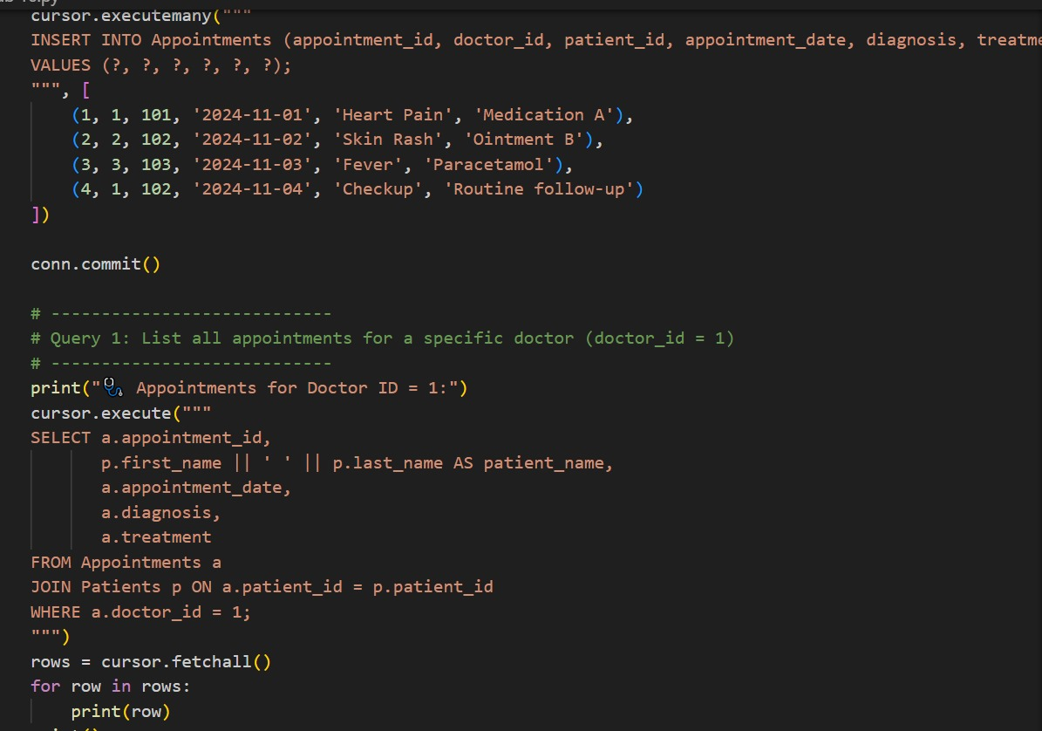
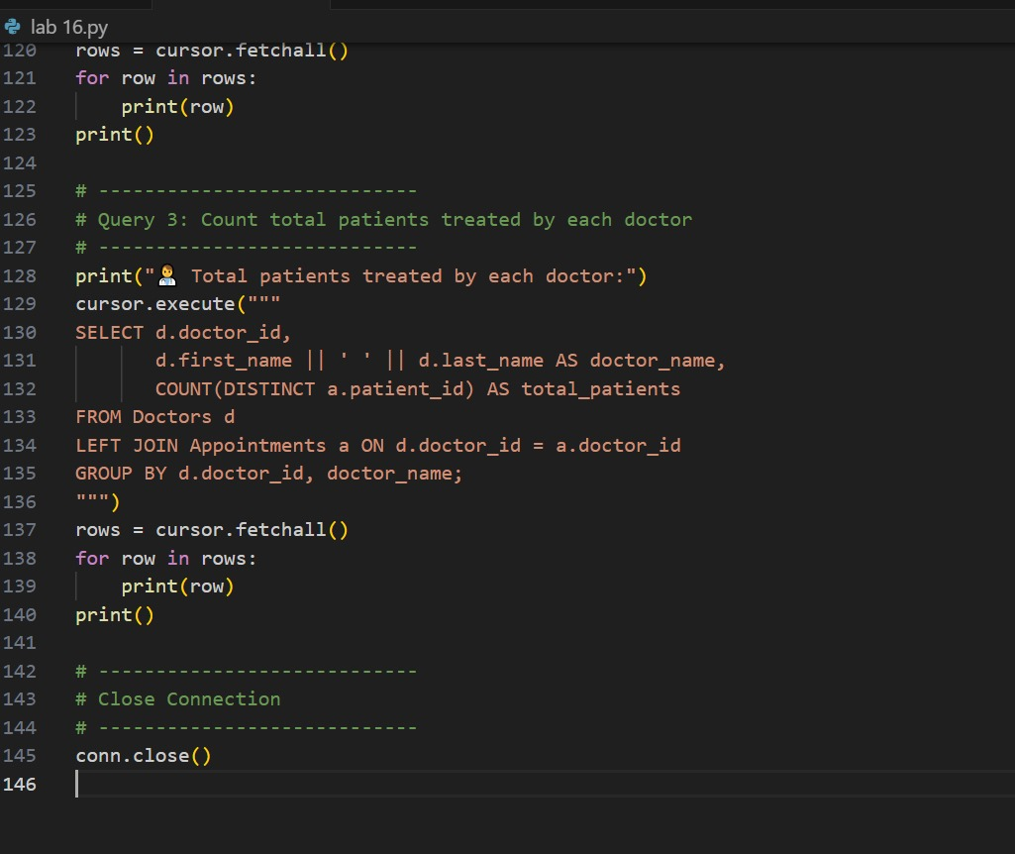
Expected Output:
• Normalized schema and SQL queries with joins.

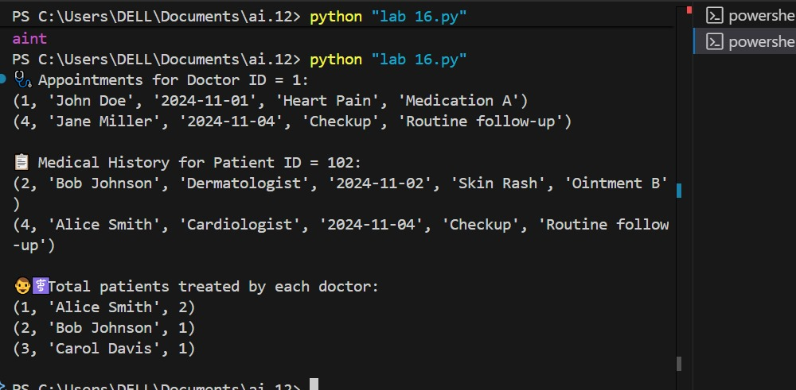
Task 3 – Library Database
Task:
Design schema for a Library Management System.
Instructions:
• Tables: Books, Members, Loans.
• Use AI to suggest indexing strategy for faster queries.
• Generate queries:
o Retrieve all books currently issued.
o Find overdue books (loan date > 30 days).
o Count number of books loaned by each member.
PROMPT:
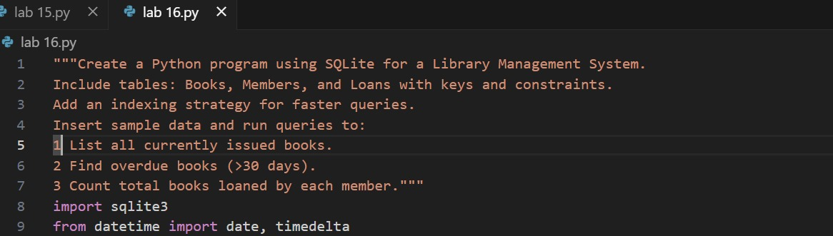
CODE:
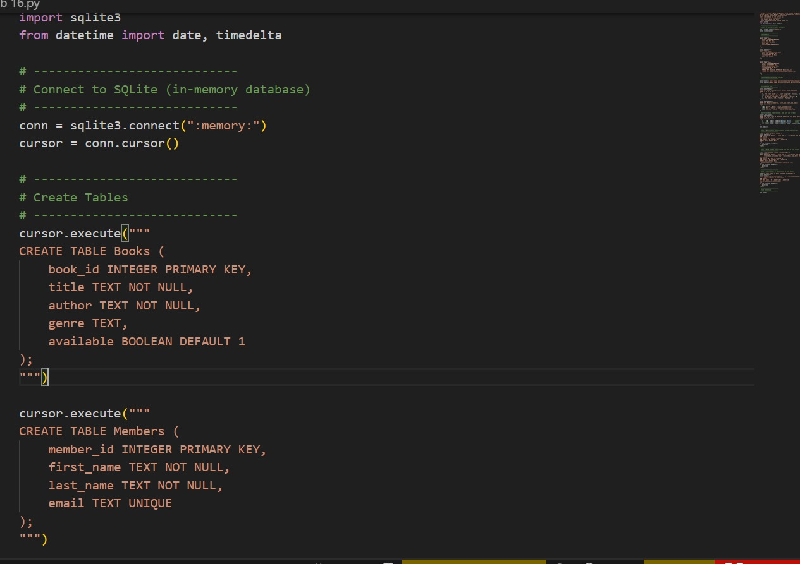
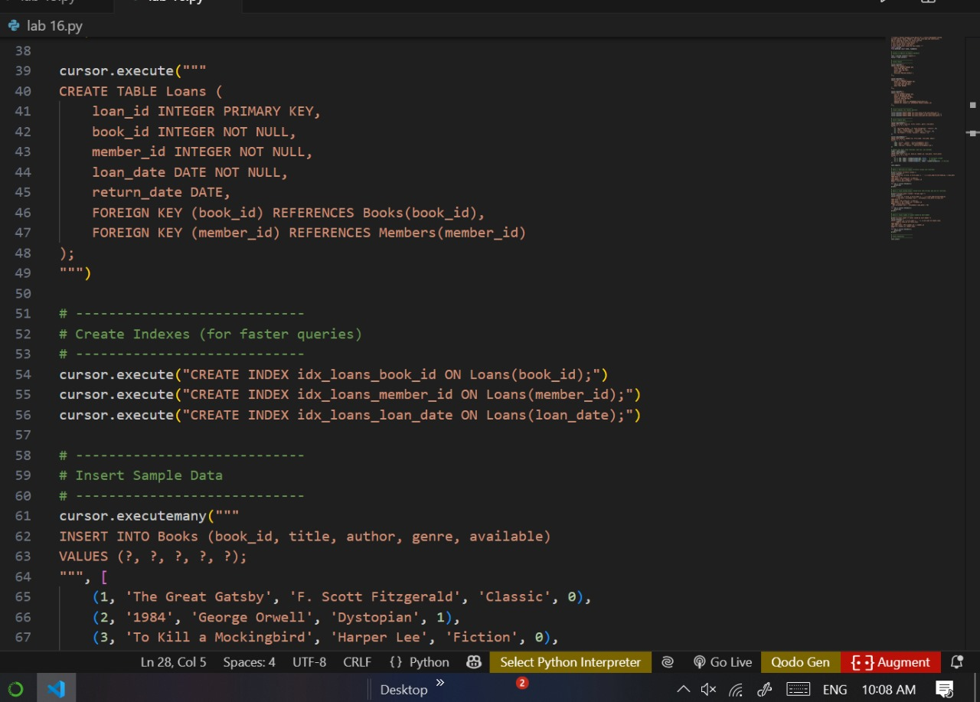

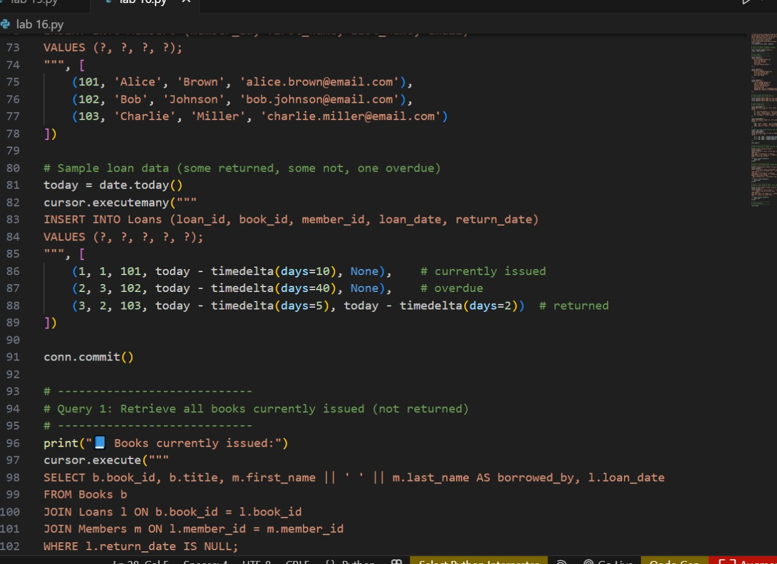
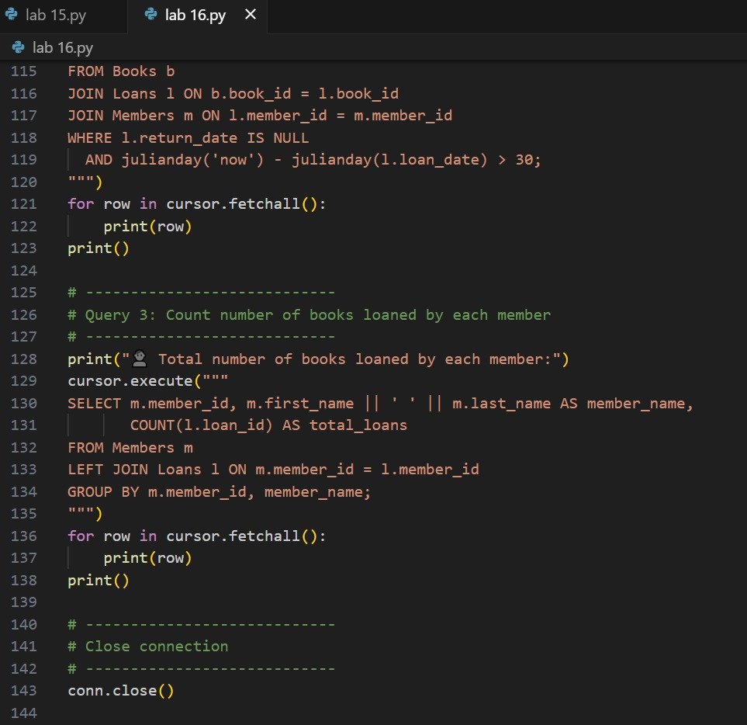
Expected Output:
• Schema + SQL queries demonstrating joins and conditions.

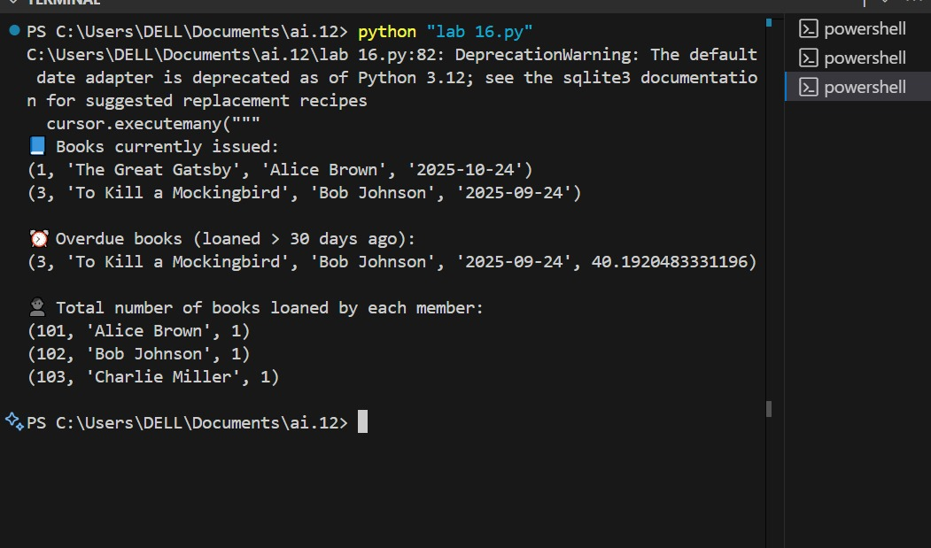
Task 4 – Real-Time Application: Online Shopping Database
Scenario:
Design a database for an E-commerce platform.
Requirements:
• Tables: Users, Products, Orders, OrderDetails.
• Generate queries to:
o Retrieve all orders by a user.
o Find the most purchased product.
o Calculate total revenue in a given month.
• AI should also suggest normalization improvements and query
optimization.
PROMPT:
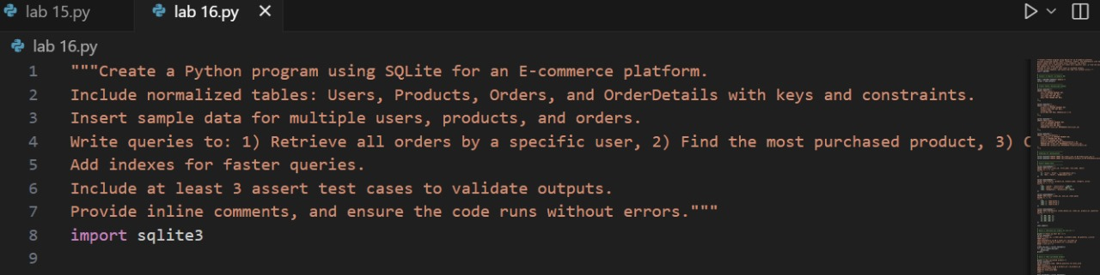
CODE:
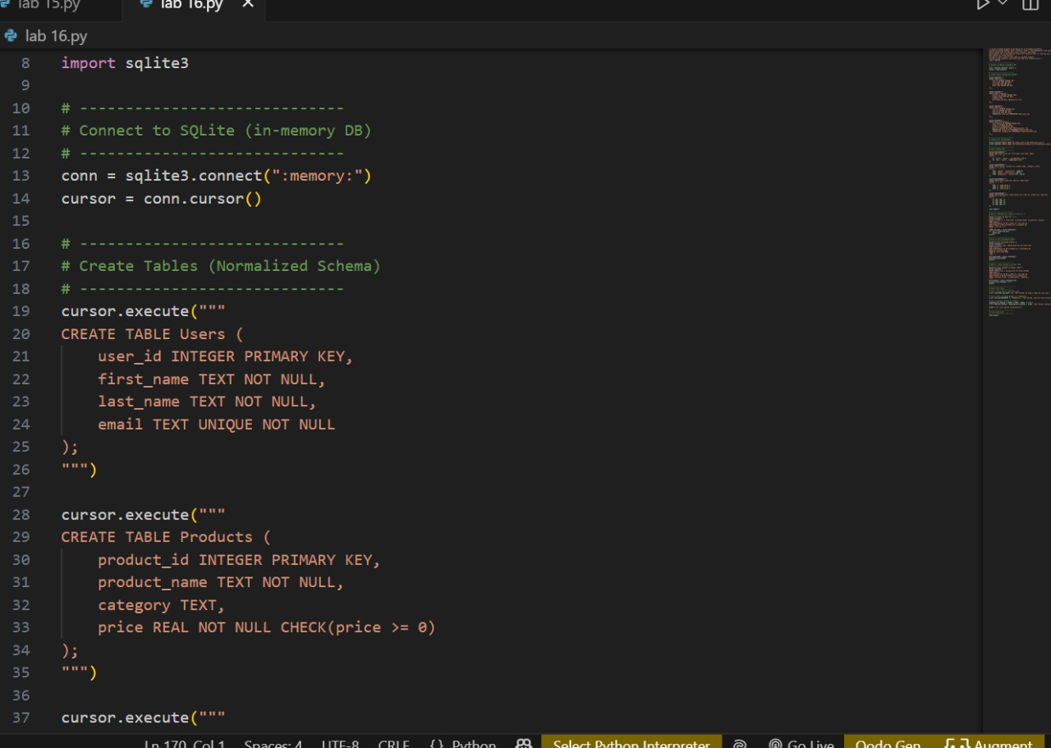
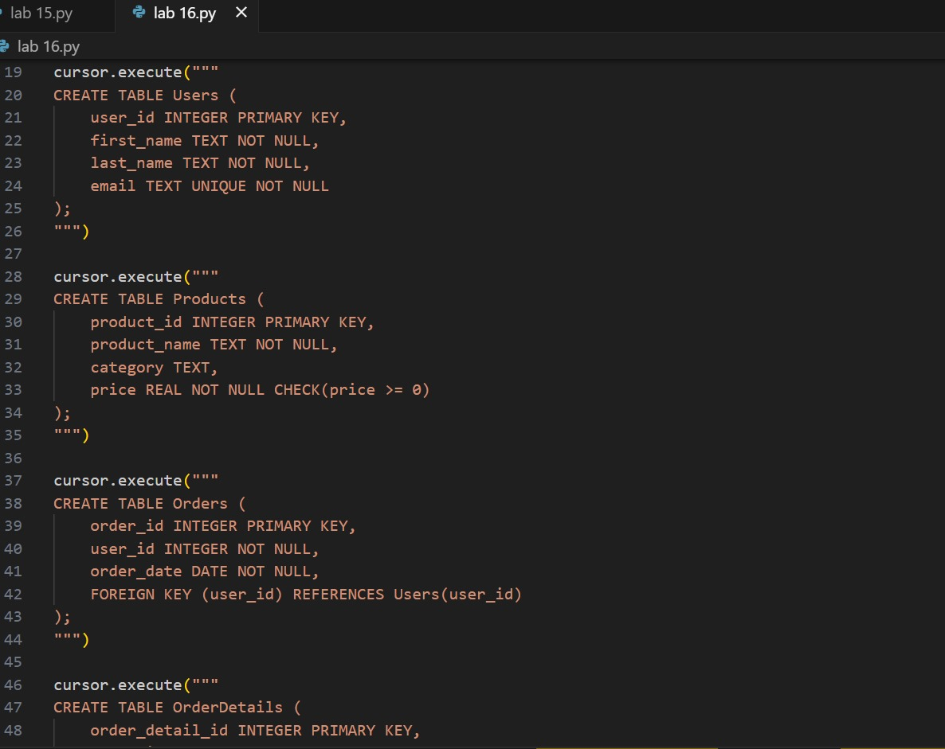

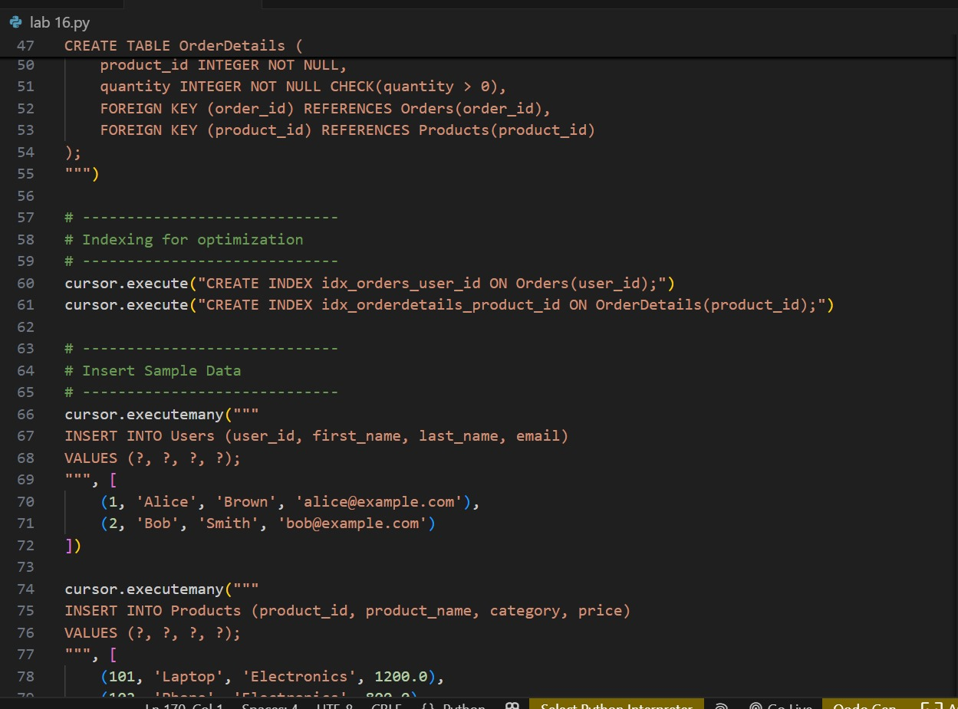
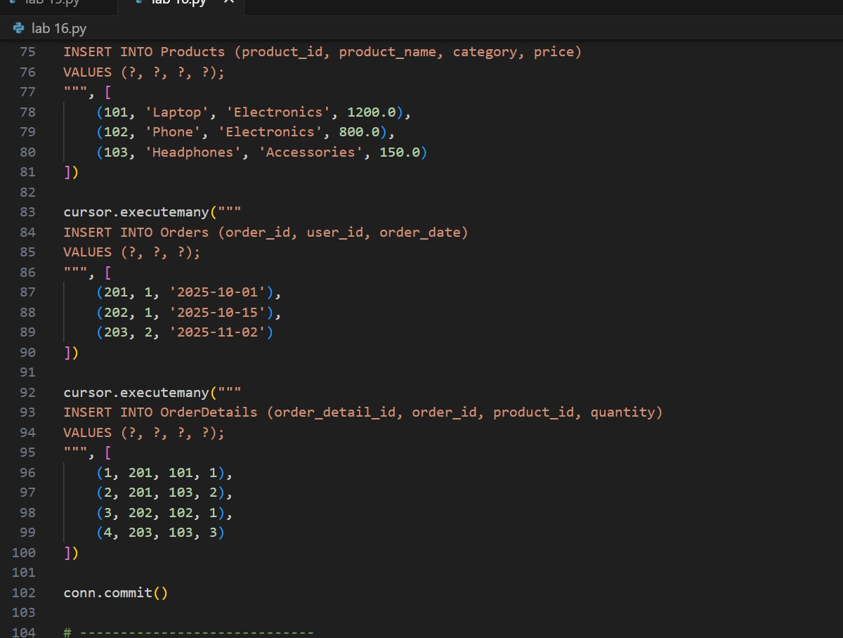
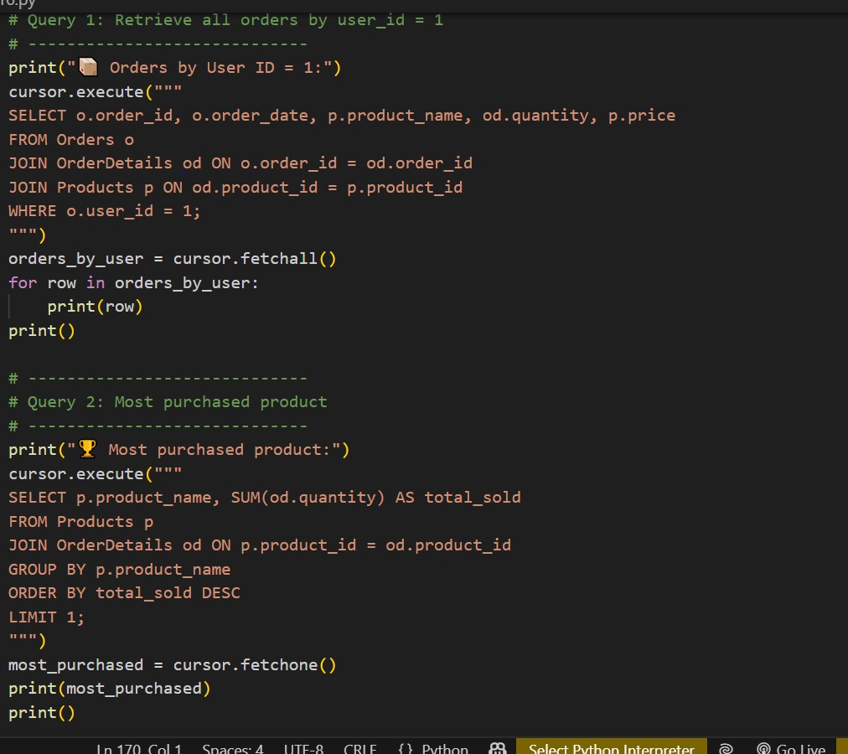
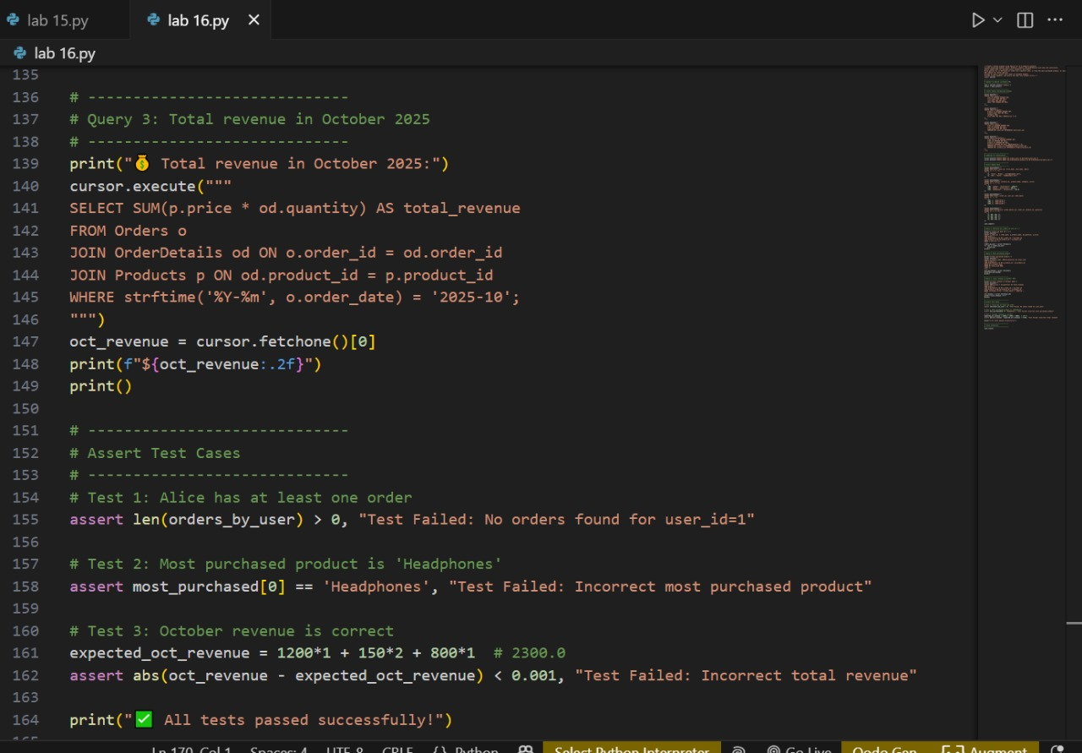

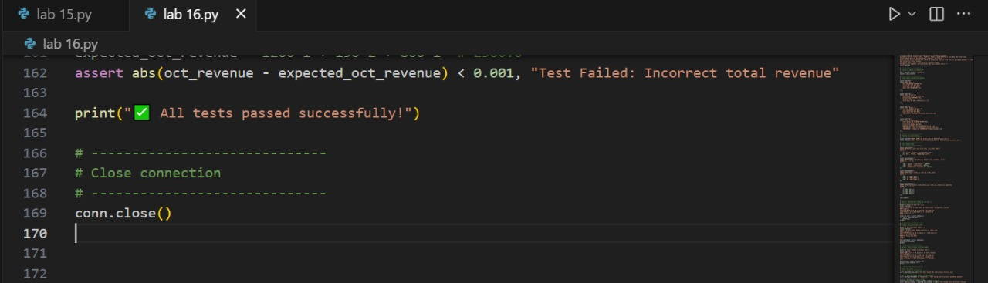

Expected Output:
• Complete schema with relationships + SQL queries for analytics.
Deliverables (For All Tasks)
1. AI-generated prompts for code and test case generation.
2. At least 3 assert test cases for each task.
3. AI-generated initial code and execution screenshots.
4. Analysis of whether code passes all tests.
5. Improved final version with inline comments and explanation.
6. Compiled report (Word/PDF) with prompts, test cases, assertions,
code, and output.
